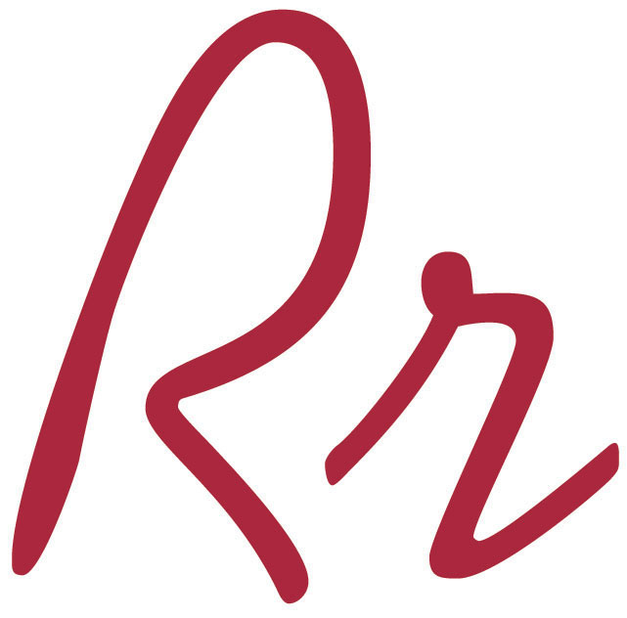
Kensington Intermediate School
20140 Lake Road • Rocky River • Ohio 44116
440.356.6770 • murphy.todd@rrcs.org • www.rrcs.org
Todd Murphy, Principal
______________________________________________________________________________

Healthy and Peanut Free
Snacks
Dear Kensington Families,

There are several students in your child’s classroom that have severe, life-threatening allergies to nuts; including peanuts, peanut butter, pecans, walnuts, nut oils (i.e. peanut oil), nut flavorings (i.e. almond extract), etc. It is possible that contact with nut residue (even from the fingers of a non-allergy student) is enough to trigger an anaphylaxis life-threatening attack.

Safety for all our children is a priority at Kensington. As parents send their children off to school in the morning, we want them to feel confident that Kensington is doing everything they can to protect their children from all dangers, even if the danger is food.

As a school, we are encouraging “healthy snacking”. By instituting some thoughtful consideration into the classroom “snack plan”, we can make the classroom a safe place for our students. We are asking parents to be conscientious in the selection of daily snacks and birthday treats that their children bring to school in an attempt to limit the chances of children being exposed to nuts. We do highly encourage that birthday treats be non-food items (stickers, pencils, erasers, etc.).

Not only do we want to encourage peanut free snacks, we want to ask parents to send in healthy snacks (fruits, veggies, raisins, crackers, etc.). We have included a list of possible snack foods that may not contain peanut traces. **The only way to be absolutely sure is to read the label carefully, even paying attention to “traces of nuts”.

We thank you in advance for your consideration in making the school environment safe for all our Kensington children. Together we can make a difference for children.

Suggestions:
Snacks: Fresh fruits and vegetables are encouraged.

Respectfully,

Mr. Todd Murphy Mrs. Barbara Reddy
Principal School Nurse

